Министерство образования и науки Российской Федерации

Федеральное государственное автономное образовательное учреждение

высшего образования

МОСКОВСКИЙ ПОЛИТЕХНИЧЕСКИЙ УНИВЕРСИТЕТ

(МОСКОВСКИЙ ПОЛИТЕХ)

Лабораторная работа «Реализация структуры Data Vault»

По дисциплине

«Хранилища данных»

Факультет «Информационные технологии»

Кафедра «Прикладная информатика»

Группа 203-321

Студентка __________Д.С. Комарова

Преподаватель __________В.С Ноздрин

Москва 2024 г.

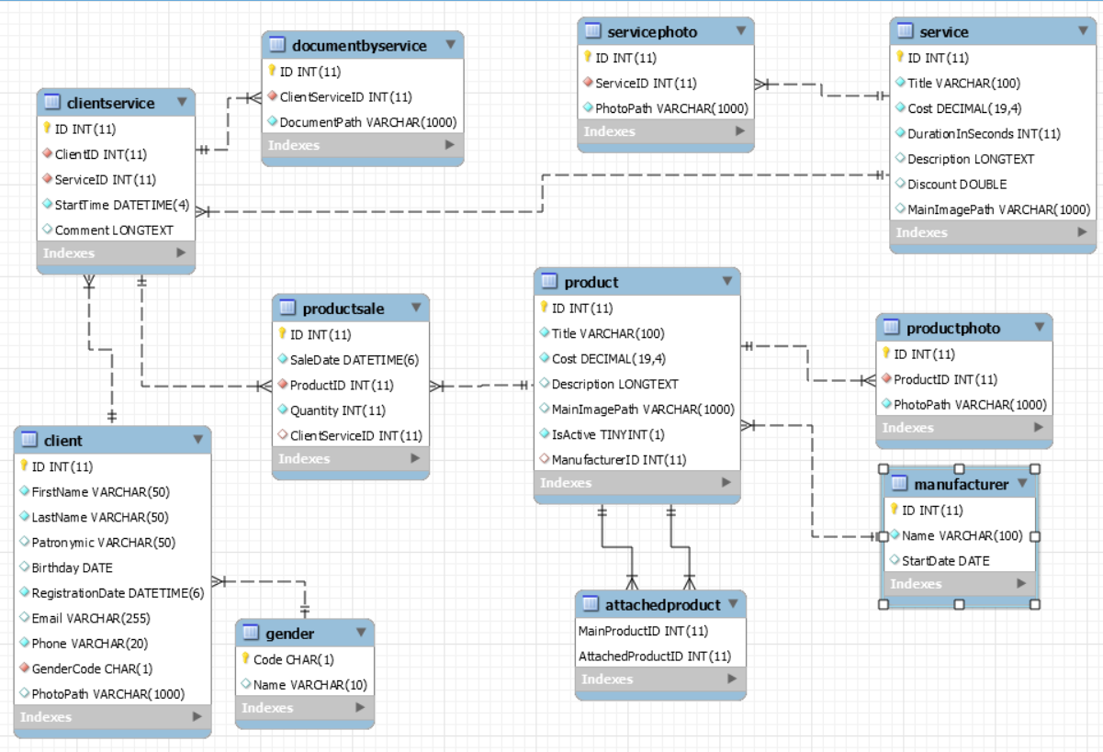

Рис.1 структура базы данных

Для реализации на сайте я создала таблицы с помощью MySQL Workbench (с листингом):

CREATE DATABASE `beautysaloon`;

USE `beautysaloon`;

CREATE TABLE `attachedproduct` (

`MainProductID` int(11) NOT NULL,

`AttachedProductID` int(11) NOT NULL,

PRIMARY KEY (`MainProductID`,`AttachedProductID`),

KEY `FK_AttachedProduct_Product1` (`AttachedProductID`),

CONSTRAINT `FK_AttachedProduct_Product` FOREIGN KEY (`MainProductID`) REFERENCES `product` (`ID`),

CONSTRAINT `FK_AttachedProduct_Product1` FOREIGN KEY (`AttachedProductID`) REFERENCES `product` (`ID`)

) ;

CREATE TABLE `client` (

`ID` int(11) NOT NULL AUTO_INCREMENT,

`FirstName` varchar(50) NOT NULL,

`LastName` varchar(50) CHARACTER SET utf8 COLLATE utf8_unicode_ci NOT NULL,

`Patronymic` varchar(50) DEFAULT NULL,

`Birthday` date DEFAULT NULL,

`RegistrationDate` datetime(6) NOT NULL,

`Email` varchar(255) DEFAULT NULL,

`Phone` varchar(20) NOT NULL,

`GenderCode` char(1) NOT NULL,

`PhotoPath` varchar(1000) DEFAULT NULL,

PRIMARY KEY (`ID`),

KEY `FK_Client_Gender` (`GenderCode`),

CONSTRAINT `FK_Client_Gender` FOREIGN KEY (`GenderCode`) REFERENCES `gender` (`Code`)

);

CREATE TABLE `clientservice` (

`ID` int(11) NOT NULL AUTO_INCREMENT,

`ClientID` int(11) NOT NULL,

`ServiceID` int(11) NOT NULL,

`StartTime` datetime(4) NOT NULL,

`Comment` longtext DEFAULT NULL,

PRIMARY KEY (`ID`),

KEY `FK_ClientService_Client` (`ClientID`),

KEY `FK_ClientService_Service` (`ServiceID`),

CONSTRAINT `FK_ClientService_Client` FOREIGN KEY (`ClientID`) REFERENCES `client` (`ID`),

CONSTRAINT `FK_ClientService_Service` FOREIGN KEY (`ServiceID`) REFERENCES `service` (`ID`)

);

CREATE TABLE `documentbyservice` (

`ID` int(11) NOT NULL AUTO_INCREMENT,

`ClientServiceID` int(11) NOT NULL,

`DocumentPath` varchar(1000) NOT NULL,

PRIMARY KEY (`ID`),

KEY `FK_DocumentByService_ClientService` (`ClientServiceID`),

CONSTRAINT `FK_DocumentByService_ClientService` FOREIGN KEY (`ClientServiceID`) REFERENCES `clientservice` (`ID`)

);

CREATE TABLE `gender` (

`Code` char(1) NOT NULL,

`Name` varchar(10) DEFAULT NULL,

PRIMARY KEY (`Code`)

);

CREATE TABLE `manufacturer` (

`ID` int(11) NOT NULL AUTO_INCREMENT,

`Name` varchar(100) NOT NULL,

`StartDate` date DEFAULT NULL,

PRIMARY KEY (`ID`)

);

CREATE TABLE `product` (

`ID` int(11) NOT NULL AUTO_INCREMENT,

`Title` varchar(100) NOT NULL,

`Cost` decimal(19,4) NOT NULL,

`Description` longtext DEFAULT NULL,

`MainImagePath` varchar(1000) DEFAULT NULL,

`IsActive` tinyint(1) NOT NULL,

`ManufacturerID` int(11) DEFAULT NULL,

PRIMARY KEY (`ID`),

KEY `FK_Product_Manufacturer` (`ManufacturerID`),

CONSTRAINT `FK_Product_Manufacturer` FOREIGN KEY (`ManufacturerID`) REFERENCES `manufacturer` (`ID`)

);

CREATE TABLE `productphoto` (

`ID` int(11) NOT NULL AUTO_INCREMENT,

`ProductID` int(11) NOT NULL,

`PhotoPath` varchar(1000) NOT NULL,

PRIMARY KEY (`ID`),

KEY `FK_ProductPhoto_Product` (`ProductID`),

CONSTRAINT `FK_ProductPhoto_Product` FOREIGN KEY (`ProductID`) REFERENCES `product` (`ID`)

);

CREATE TABLE `productsale` (

`ID` int(11) NOT NULL AUTO_INCREMENT,

`SaleDate` datetime(6) NOT NULL,

`ProductID` int(11) NOT NULL,

`Quantity` int(11) NOT NULL,

`ClientServiceID` int(11) DEFAULT NULL,

PRIMARY KEY (`ID`),

KEY `FK_ProductSale_Product` (`ProductID`),

KEY `FK_ProductSale_ClientService` (`ClientServiceID`),

CONSTRAINT `FK_ProductSale_ClientService` FOREIGN KEY (`ClientServiceID`) REFERENCES `clientservice` (`ID`),

CONSTRAINT `FK_ProductSale_Product` FOREIGN KEY (`ProductID`) REFERENCES `product` (`ID`)

);

CREATE TABLE `service` (

`ID` int(11) NOT NULL AUTO_INCREMENT,

`Title` varchar(100) NOT NULL,

`Cost` decimal(19,4) NOT NULL,

`DurationInSeconds` int(11) NOT NULL,

`Description` longtext DEFAULT NULL,

`Discount` double DEFAULT NULL,

`MainImagePath` varchar(1000) DEFAULT NULL,

PRIMARY KEY (`ID`)

);

CREATE TABLE `servicephoto` (

`ID` int(11) NOT NULL AUTO_INCREMENT,

`ServiceID` int(11) NOT NULL,

`PhotoPath` varchar(1000) NOT NULL,

PRIMARY KEY (`ID`),

KEY `FK_ServicePhoto_Service` (`ServiceID`),

CONSTRAINT `FK_ServicePhoto_Service` FOREIGN KEY (`ServiceID`) REFERENCES `service` (`ID`)

);